

Department of Computer Science
Program: BS Computer Science

Course Number | CSC103
Section Number | C
Course Title | Programming Fundamentals
Semester/Year | I / 2020

Instructor

PROPOSAL FOR PROJECT No. | 01

Project Title | TIC-TAC-TOE GAME

Submission Date | 28-02-2020

Team of Student’s
Student ID
Signature*

TIC-TAC-TOE GAME

Introduction: ic-tac-toe is not a very challenging game for human beings. If you’re an enthusiast, you’ve
probably moved from the basic game to some variant like three dimensional tic-tac-toe on
a larger grid. If you sit down right now to play ordinary three-by-three tic-tac-toe with a friend,
what will probably happen is that every game will come out a tie. Both you and your friend
can probably play perfectly, never making a mistake that would allow your opponent to win. But
can you describe how you know where to move each turn? Most of the time, you probably aren’t
even aware of alternative possibilities; you just look at the board and instantly know where you
want to move. That kind of instant knowledge is great for human beings, because it makes you a
fast player.
But it isn’t much help in writing a computer program. For that, you have to know very explicitly
what your strategy is.
Tic-tac-toe is a casual strategy game for everyone. It is easy to teach, and the player can play this
game almost everywhere. Because it only requires a writing tool and a writable surface.
Vandalism is not recommended
ic-tac-toe is not a very challenging game for human beings. If you’re an enthusiast, you’ve
probably moved from the basic game to some variant like three dimensional tic-tac-toe on
a larger grid. If you sit down right now to play ordinary three-by-three tic-tac-toe with a friend,
what will probably happen is that every game will come out a tie. Both you and your friend
can probably play perfectly, never making a mistake that would allow your opponent to win. But
can you describe how you know where to move each turn? Most of the time, you probably aren’t
even aware of alternative possibilities; you just look at the board and instantly know where you
want to move. That kind of instant knowledge is great for human beings, because it makes you a
fast player.
But it isn’t much help in writing a computer program. For that, you have to know very explicitly
what your strategy is.
Tic-tac-toe is a casual strategy game for everyone. It is easy to teach, and the player can play this
game almost everywhere. Because it only requires a writing tool and a writable surface.
Vandalism is not recommended
ic-tac-toe is not a very challenging game for human beings. If you’re an enthusiast, you’ve
probably moved from the basic game to some variant like three dimensional tic-tac-toe on
a larger grid. If you sit down right now to play ordinary three-by-three tic-tac-toe with a friend,
what will probably happen is that every game will come out a tie. Both you and your friend
can probably play perfectly, never making a mistake that would allow your opponent to win. But
can you describe how you know where to move each turn? Most of the time, you probably aren’t
even aware of alternative possibilities; you just look at the board and instantly know where you
want to move. That kind of instant knowledge is great for human beings, because it makes you a
fast player.
But it isn’t much help in writing a computer program. For that, you have to know very explicitly
what your strategy is.
Tic-tac-toe is a casual strategy game for everyone. It is easy to teach, and the player can play this
game almost everywhere. Because it only requires a writing tool and a writable surface.
Vandalism is not recommended
ic-tac-toe is not a very challenging game for human beings. If you’re an enthusiast, you’ve
probably moved from the basic game to some variant like three dimensional tic-tac-toe on
a larger grid. If you sit down right now to play ordinary three-by-three tic-tac-toe with a friend,
what will probably happen is that every game will come out a tie. Both you and your friend
can probably play perfectly, never making a mistake that would allow your opponent to win. But
can you describe how you know where to move each turn? Most of the time, you probably aren’t
even aware of alternative possibilities; you just look at the board and instantly know where you
want to move. That kind of instant knowledge is great for human beings, because it makes you a
fast player.
But it isn’t much help in writing a computer program. For that, you have to know very explicitly
what your strategy is.
Tic-tac-toe is a casual strategy game for everyone. It is easy to teach, and the player can play this
game almost everywhere. Because it only requires a writing tool and a writable surface.
Vandalism is not recommended
ic-tac-toe is not a very challenging game for human beings. If you’re an enthusiast, you’ve
probably moved from the basic game to some variant like three dimensional tic-tac-toe on
a larger grid. If you sit down right now to play ordinary three-by-three tic-tac-toe with a friend,
what will probably happen is that every game will come out a tie. Both you and your friend
can probably play perfectly, never making a mistake that would allow your opponent to win. But
can you describe how you know where to move each turn? Most of the time, you probably aren’t
even aware of alternative possibilities; you just look at the board and instantly know where you
want to move. That kind of instant knowledge is great for human beings, because it makes you a
fast player.
But it isn’t much help in writing a computer program. For that, you have to know very explicitly
what your strategy is.
Tic-tac-toe is a casual strategy game for everyone. It is easy to teach, and the player can play this
game almost everywhere. Because it only requires a writing tool and a writable surface.
Vandalism is not recommended
INTRODUCTION: Tic-tac-toe (also known as noughts and crosses or X and O) is a paper-and-pencil game for two players, X and O, who take turns marking the spaces in a 3×3 grid. The player who succeeds in placing three of their marks in a horizontal, vertical, or diagonal row wins the game. Tic-tac-toe is not a very challenging game for human beings. what will probably happen is that every game will come out a tie. Both you and your friend can probably play perfectly, never making a mistake that would allow your opponent to win.
what will probably happen is that every game will come out a tie. Both you and your friend can probably play perfectly, never making a mistake that would allow your opponent to win.
History: The Roman Empire is known to have established the beginnings of the earliest known variant of tic-tac-toe. It originated around the first century BC. At that time, the game was called Terni Lapilli. Instead of having any number of pieces, each player only had three. The game was played by moving them around to empty spaces to keep playing. However, according to Claudia Zaslavsky’s book, the game Tic Tac Toe is originating from ancient Egypt.
Rules of the Game:
• The game is to be played between two people (in this program between Player 1 and Player 2).
• One of the players chooses ‘O’ and the other ‘X’ to mark their respective cells.
• The game starts with one of the players and the game ends when one of the players has one whole row/ column/ diagonal filled with his/her respective character (‘O’ or ‘X’).
A player can play perfect tic-tac-toe (win or draw) given they move according to the highest possible move from the following table.
- Win: If the player has two in a row, play the third to get three in a row.
- Block: If the opponent has two in a row, play the third to block them.
- Fork: Create an opportunity where you can win in two ways.
- Center: Play the center.

- Opposite corner: If the opponent is in the corner, play the opposite corner.
- Empty corner: Play in a corner square.
- Empty side: Play in a middle square on any of the 4 sides.

Implementation:
- Use any method to find who will start first.
- Then each player taking turn draw their symbol on a space from that nine possible spaces.
- The one who met the winning condition first win. If after nine possible spaces are
used, but no one wins, that game is a draw.

Goal: The goal of this game is to be the first one who draws three of the player’s symbol to form one of these winning conditions.

Winning Condition:
These are the acceptable win condition of this game
Winning Condition:
These are the acceptable win condition of this game
Winning Condition: These are the acceptable win condition of this game.
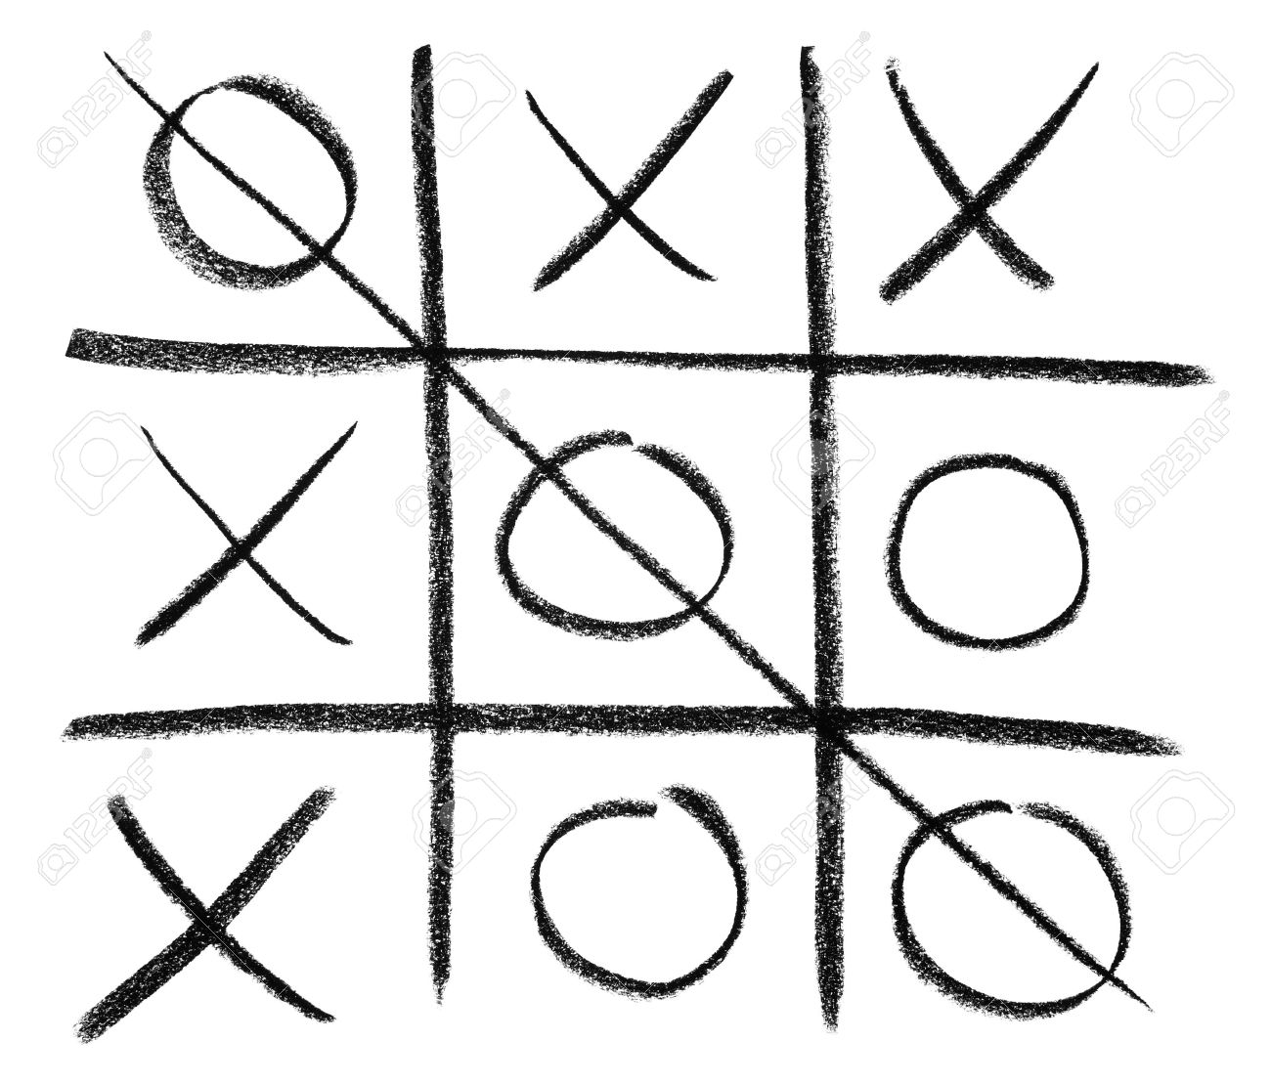

The player who controls O symbol won by drawing the three symbols in a diagonal line.

Learning Game: This classic game contributes to children's developmental growth in numerous ways including their understanding of predictability, problem solving, spatial reasoning, hand-eye coordination, turn taking, and strategizing.

IDE:
- Turbo C++
- CodeBlocks

